|  |  |
| --- | --- |
| Electrical Circuits | Just Science    Emma Harrage |

**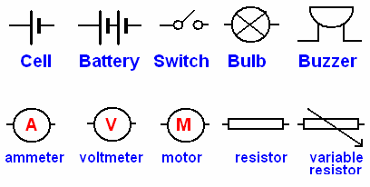Circuit Symbols**

**Please complete Activity 1 and 2**

**CIRCUITS**

A circuit is made up of wires and components with a power source where current can flow and the components will do work.

A simple circuit is where a bulb is connected to a power source so the bulb can give off light.This is called a *simple series circuit.*

**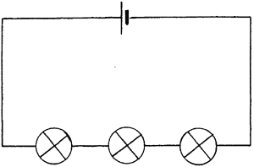**

This is a simple series circuit with 3 bulbs and 1 cell

**Electric current**

When electric charges move in a wire, we say that an **electric current** flows in the wire. It's like the way a current of water flows in a river.

Current is the movement of electrons around a circuit. According to convention electrons flow from the negative side of the battery to the positive side of the battery. *(this makes sense really because electrons are negative and will be attracted to the positive side of the battery) but it is wrong!*

Electrons flow from the negative side of the battery to the positive side.

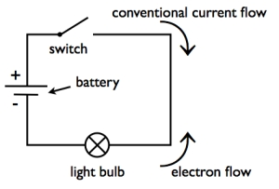

For an electric current to flow, we need two things:

* something to make the electricity flow, such as a battery or power pack
* a complete path for the current to flow in.

**Electric circuits**

An electric current will not flow if we do not have a **power source** (a cell, battery or power pack). It also won't flow if the circuit is not **complete**. One end of the power source must be joined to the other end by the wires and components of the circuit.

The simplest complete circuit is a piece of wire from one end of a battery to the other. An electric current can flow in the wire from one end of the battery to the other, but nothing useful happens. The wire just gets hot and the battery goes flat.

To do something useful with the electric current, we need to put an electrical **component** into the circuit, such as a lamp or motor that can use the current to make something happen.

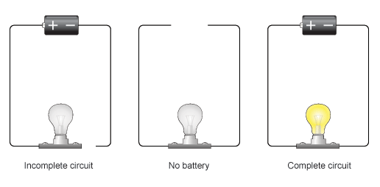

The bulb will only light if there is a battery and a complete circuit

We usually add in a **switch** to the circuit, so that we can break the circuit and stop the electric current when we want to.

## Series circuits

In a television series, you get several episodes, one after the other. A series circuit is similar. You get several components one after the other.

If you follow the circuit diagram from one side of the cell to the other, you should pass through all the different components, one after the other, without any branches.

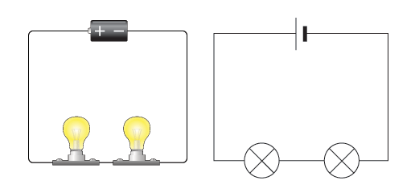

If you put more lamps into a series circuit, the lamps will be dimmer than before.

In a series circuit, if a lamp breaks or a component is disconnected, the circuit is broken and all the components stop working.

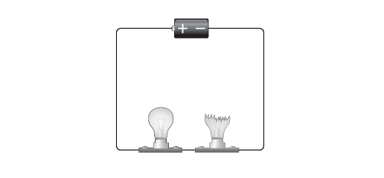

Series circuits are useful if you want a warning that one of the components in the circuit has failed. They also use less wiring than parallel circuits.

## Circuit diagrams

The idea of a circuit diagram is to use circuit symbols instead of drawing each component in the circuit. Always try to make the wires **straight** lines, and don't be tempted to make them wiggly.

The whole point is to make it easier to see what is connected to what. Here you can see how the symbols for a cell (not a battery!) and a lamp look in a circuit diagram.

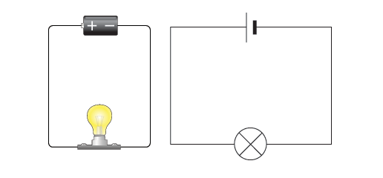

If you have to draw a circuit diagram from scratch, it is usually easier to draw the circuit symbols first, and then add all the wires. When you have to draw wires to join circuit symbols that are already shown, use a ruler and don't let the wires cross each other.

**When you are drawing circuits you MUST:**

1. ***Use a sharp pencil and a ruler***
2. ***Make sure your lines are straight and all angles are at 90°***
3. ***Leave no gaps between wires and /or components***

**Current in series circuits**

The current is the same everywhere in a **series circuit**. It does not matter where you put the ammeter, it will give you the same reading.

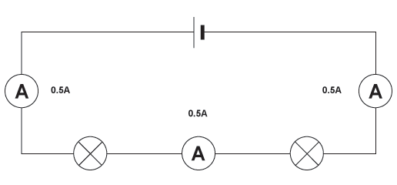

All three ammeters give the same reading in this series circuit

**Adding more cells**

The current in a series circuit depends upon the number of cells. The more cells you add, the greater the current.

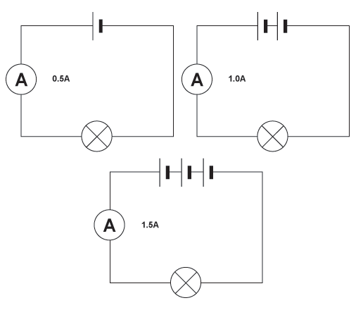

The more cells, the greater the current.

**Current is not used up**

You might think that the current gets less as it flows through one component after another. But it is not like this. The current is not used up by the components in a circuit. This means that the current is the same everywhere in a series circuit, even if it has lots of lamps or other components.

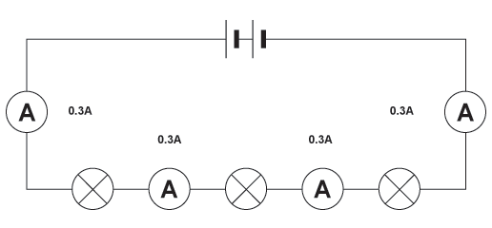

The current is the same everywhere in a series circuit.

----------------------------------------------------------------------

**Please complete activities 3 and 8.**

**And then**

**Class practical’s –Activities: 4,5,6**

----------------------------------------------------------

# Series & parallel circuits

There are two types of circuit we can make, called **series** and **parallel**.

The components in a circuit are joined by wires.

* if there are no branches then it's a series circuit
* if there are branches it's a parallel circuit

## Parallel circuits

In parallel circuits different components are connected on different branches of the wire. If you follow the circuit diagram from one side of the cell to the other, you can only pass through all the different components if you follow all the **branches**.

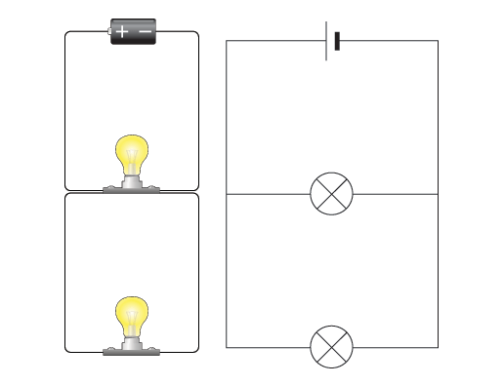

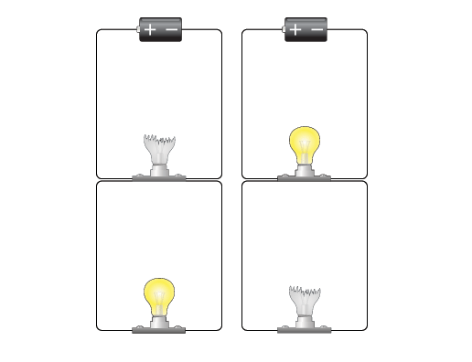In a parallel circuit, if a lamp breaks or a component is disconnected from one parallel wire, the components on different branches **keep working**. And, unlike a series circuit, the lamps stay bright if you add more lamps in parallel.

Parallel circuits are useful if you want everything to work, even if one component has failed. This is why our homes are wired up with parallel circuits.

Get a red, blue and purple pen……..



|  |  |
| --- | --- |
|  |  |

# Measuring amps & volts

You need to know how to measure current and voltage.

## Current

Current is a measure of how much **electric charge** flows through a circuit. The more charge that flows, the bigger the current.

Current is measured in units called **amps**. The symbol for amps is **A**. For example, 20A is a bigger current than 5A.

### Measuring current

A device called an ammeter is used to measure current. Some types of ammeter have a pointer on a dial, but most have a digital readout. To measure the current flowing through a component in a circuit, you must connect the ammeter in **series** with it.

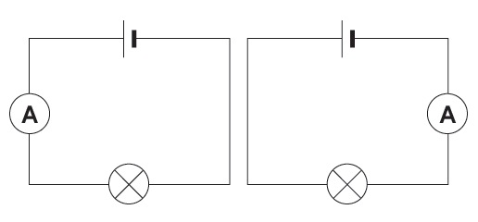

## Voltage

Voltage is a measure of the difference in **electrical energy** between two parts of a circuit. The bigger the difference in energy, the bigger the voltage.

Voltage is measured in **volts**. The symbol for volts is **V**. For example, 230V is a bigger voltage than 12V.

### Measuring voltage

Voltage is measured using a voltmeter. Some types of voltmeter have a pointer on a dial, but most have a digital readout. To measure the voltage across a component in a circuit, you must connect the voltmeter in **parallel** with it.

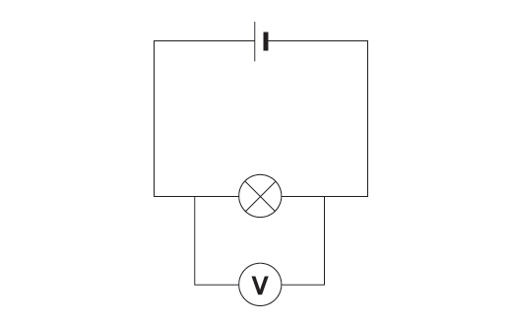

You can measure the voltage across a cell or battery.

The more cells, the bigger the voltage.

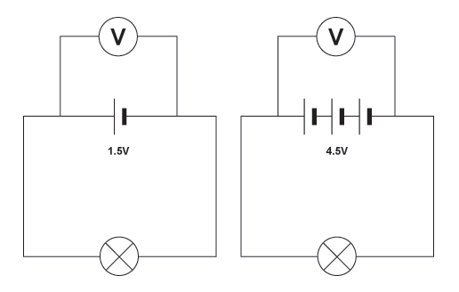

Complete Activity 7

Activity 1: Practise drawing the symbols in the table below:

|  |  |  |  |  |
| --- | --- | --- | --- | --- |
| **Symbol** | **Symbol** | **Symbol** | **Name** | **Function** |
|  |  |  |  |  |
|  |  |  |  |  |
|  |  |  |  |  |
|  |  |  |  |  |
|  |  |  |  |  |
|  |  |  |  |  |
|  |  |  |  |  |
|  |  |  |  |  |
|  |  |  |  |  |
|  |  |  |  |  |

Activity 2: Match the symbol to the correct name.

|  |  |  |
| --- | --- | --- |
| ammeter |  | motor |
| battery |  | cell |
| bulb |  | voltmeter |
| buzzer |  | ammeter |
| cell |  | battery |
| closedswitch |  | buzzer |
| motor |  | open switch |
| openswitch |  | bulb |
| resistor |  | resistor |
| volt |  | closed switch |

Activity 3: Answer the following questions in the space provided.

Nikki tries to set up four electric circuits.



diagram 1

(a) In diagram 1 the ammeter reading is zero. What is wrong with this circuit?

.....................................................................................................................

.....................................................................................................................

1 mark



diagram 2

(b) In diagram 2 the ammeter reading is zero. What is wrong with this circuit?

.....................................................................................................................

.....................................................................................................................

1 mark



diagram 3

(c) In diagram 3 the ammeter reading is zero. Why is this **not** a complete circuit?

.....................................................................................................................

.....................................................................................................................

1 mark



diagram 4

(d) In diagram 4, why is there a reading on the ammeter?

.....................................................................................................................

.....................................................................................................................

1 mark

**Activity 4:**

**Series Circuit Investigation 1**

**Method**

**You are going to build all of the circuits below.**

Notice that the number of lamps increases as you go down and the number of cells increases as you go right.

Build the first circuit and call the brightness ‘**normal’** (even if it looks quite dim). Write the word normal underneath the circuit. Work your way through the rest of the circuits and decide the brightness of each bulb **compared with ‘normal’.** Put your results in the table.

Check the effect of breaking the circuit at various places.

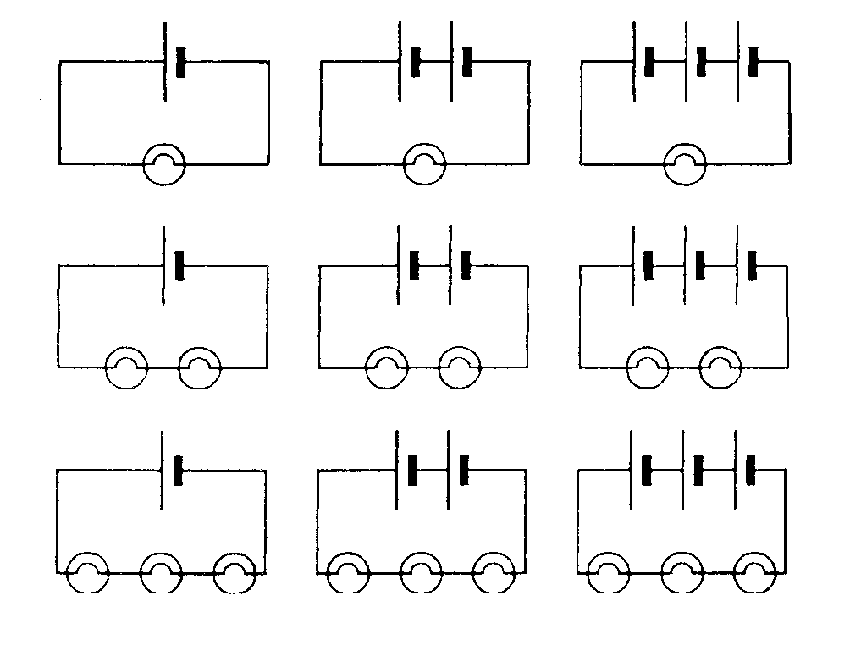

**Results**

|  |  |  |  |
| --- | --- | --- | --- |
| **Brightness** | **1 cell** | **2 cells** | **3 cells** |
| **1 bulb** | Normal |  |  |
| **2 bulbs** |  |  |  |
| **3 bulbs** |  |  |  |

**Conclusion**

What is the link between the brightness and the number of cells?

What is the link between the brightness and the number of bulbs?

What is the effect of breaking the circuit?

Can you predict what the effect of increasing the number of cells does to the amount of current? Test your prediction by putting ammeters into some of the circuits you made, and then use the space below to explain what happens.

**Activity 5:**

**Investigating Current in Circuits 2**

You are going to carry out an investigation to find out the following:

* What happens to the current as you increase the number of bulbs?

Draw a table to show what happens to the current as you increase the number of bulbs in your notebook.

|  |  |  |
| --- | --- | --- |
| Number of bulbs | Current (Amps) | Brightness |
|  |  |  |

Set up the three circuits shown in the pictures below then record your results.

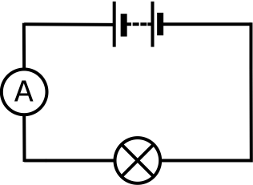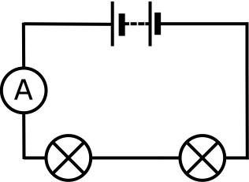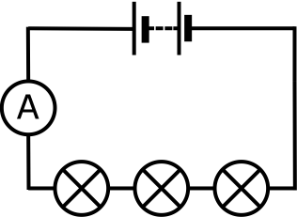

1. Write a method for your experiment. (Write down exactly what you did in numbered bullet points)

2. Draw a labelled diagram of a circuit with 2 batteries and 3 bulbs.

2. Write a conclusion by completing the sentence: “As the number of bulbs are increased the current....”. Write a similar sentence for the brightness.

3. In this investigation what was the independent variable? (What did you change).

4. What were the dependent variables? (What did you measure).

5. What were the control variables?

Activity 6: Investigating Current in a Circuit: How Does Current Change within a Circuit?

You are going to investigate how the current in a circuit changes as the electricity flows around the circuit.

Set up the circuits below. This will give you each of the ammeters readings. Write them next to your diagram.

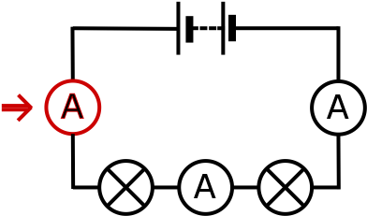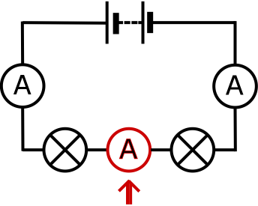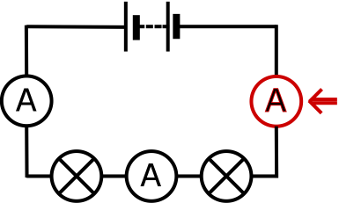

1. What do you notice about the current in a series circuit?

**Activity 7: Investigating Current In Circuits 3:**

**How Does Voltage Affect Current?**

Set up the circuit shown in the picture below. Record the bulb brightness and the current. Add another battery and repeat. Then add a third battery and repeat.

Answer the questions:

* What happens to the brightness of the bulbs as your increases the voltage of the circuit? (Change the number of batteries in the circuit)
* What happens to the current as you increase the number of batteries/size of the voltage?

**Draw a table to show your results.**

|  |  |  |
| --- | --- | --- |
| **Number of batteries** | **Current (amps)** | **Brightness of the Bulbs** |
|  |  |  |



**Conclusions**

1. Is there a relationship between the number of batteries or voltage of the power supply and the current?
2. What happens to the current when you double or treble the voltage of the power supply?
3. You can write a relationship by completing the sentence:

As you increase the voltage of the power supply the current in the circuit ..........

**Extension**

1. To make it more scientific you can write:

If you double the voltage of the power supply then the current in the circuit will also ...........

1. You can consider resistance too:

If you double the resistance of a circuit by doubling the number of bulbs then the current ............

1. Can you make a similar statement about how resistance affect current?

|  |  |  |  |  |  |  |  |  |  |  |  |  |  |  |
| --- | --- | --- | --- | --- | --- | --- | --- | --- | --- | --- | --- | --- | --- | --- |
| Activity 8  Complete the following diagrams by adding the value of the current to the blank ammeters.   |  |  | | --- | --- | | **1.** | **2.** | | **curr_circuit1** | **curr_circuit2** | | **3.** | | | **curr_circuit3** | | | **4.** | **5.** | | **curr_circuit4** | **curr_circuit5** |   **5**  Use your knowledge of how current changes in a series circuit to complete the ammeter readings from these circuits. | | |
| cd_series_2a | cd_series_3 | cd_series_1 |
| cd_series_5 | cd_series_6 | cd_series_4 |

|  |  |  |
| --- | --- | --- |
| **6**  Use your knowledge of what happens to current as you increase the number of batteries in a circuit to predict the missing ammeter readings in circuits **B** and **C** | | |
| **Acd_series_change_1** | **Bcd_series_change_2** | **Ccd_series_change_3** |
| **7**  Use your knowledge of what happens to current as the resistance of a circuit is increased to predict the missing ammeter readings for circuits **S** and **T** | | |
| **Rcd_series_change_4** | **Scd_series_change_5** | **T**cd_series_change_6 |

****

**8.** In the circuit above, both the bulbs light up. Suddenly they both go out.

The two bulbs are tested. Bulb A works but bulb B is broken.

(a)Bulb A was not broken but it went out. Why did it go out?

......................................................................................................................

......................................................................................................................

1 mark

In the circuit below, only bulb B is broken.



(b) (i) Does bulb A light up?

Tick the correct box.

Yes  No 

1 mark

(ii) Does bulb C light up?

Tick the correct box.

Yes  No  1 mark

**Activity 9: Series & Parallel Circuits REVISION**

Diagram 1 Diagram 2

B

C

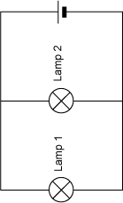

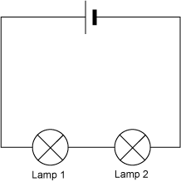

A

1. What components do the letters A, B and C represent?

A....................... B.......................... C...................................

1. What is the name given to the way the bulbs are arranged in Diagram 1?

............................................................................................................................

1. What is the name given to the way the bulbs are arranged in Diagram 2?

............................................................................................................................

1. In a series circuit, like in Diagram 1, how is the brightness of the first bulb affected when the second bulb is connected? Explain why this happens?

............................................................................................................................

............................................................................................................................

1. In a parallel circuit, like in Diagram 2, how is the brightness of the first bulb affected when the second bulb is connected? Explain why this happens?

............................................................................................................................

............................................................................................................................

1. Give one example of where we might find a series circuit in everyday life.

............................................................................................................................

1. Give one example of where we might find a parallel circuit in everyday life.

............................................................................................................................

1. Explain one advantage of using a parallel circuit rather than a series circuit.

............................................................................................................................

1. Dan and Tom build a circuit like the one shown below.

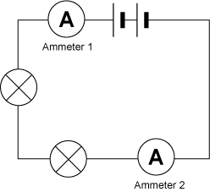

X

1. Name the component labelled X ........................................................
2. What are Dan and Tom using the component labelled X to measure? ........................
3. Dan says, “Ammeter 1 will show a lower reading than Ammeter 2 because the bulbs in the circuit use up the current.”

Tom says, “Ammeter 1 will show the same reading as Ammeter 2 because current is not used up.”

Who is right? ..................................................

1. If Ammeter 1 has a reading of 1.5A, what reading will Ammeter 2 show? ....................A
2. (a) The circuit above contains 2 cells. Describe what would happen to the bulbs if Dan and Tom added another cell.

............................................................................................................................

(b) Describe how the reading on the reading on the ammeters would change if another cell was added to the circuit.

............................................................................................................................

|  |  |  |  |  |
| --- | --- | --- | --- | --- |
| Assignment | Completed by deadline | Possible Mark | Actual Mark | Parent Signature |
| Activity 1 |  |  |  |  |
| Activity 2 |  | 10 |  |  |
| Activity 3 |  | 4 |  |  |
| Activity 4 |  |  |  |  |
| Activity 5 |  | 9 |  |  |
| Activity 6 |  |  |  |  |
| Activity 7 |  | 11 |  |  |
| Activity 8 |  | 22 |  |  |
| Activity 9 |  | 16 |  |  |
| Cycle Test |  |  |  |  |